

**UNIVERSITI TEKNIKAL MALAYSIA MELAKA**

FAKULTI TEKNOLOGI MAKLUMAT DAN KOMUNIKASI

BITP 3113

OBJECT-ORIENTED PROGRAMMING

Group Project Title

Pet Clinic Management System

Due Date:

15 December 2016

Team Members:

|  |  |
| --- | --- |
| **Name** | **Matric Card No** |
| LOW QI WEI | B031510127 |
| CHIN KON YEE | B031510363 |

**ACKNOWLEDGEMENT**

First of all, we would like to thank my workshop supervisor PROFESOR MADYA DR AZAH KAMILAH BINTI DRAMAN for guiding us through the project. We learned a lot from her remarkable insights.

Next, we would like to thank our own parents for supporting us relentlessly. Their endless support is what motivates us though not only the project, but life as well.

Lastly, we would like to express our utmost gratitude to all our friends for sharing their unique experiences as they cruise through their own OOP project.

**LIST OF CONTENTS**

|  |  |  |
| --- | --- | --- |
| **CHAPTER** | **DESCRIPTION** | **PAGE** |
|  | Acknowledgement | ii |
|  | List of Contents | iii |
| Chapter 1 | Introduction | 4 |
|  | 1.0 Introduction | 4 |
|  | 1.1 Problem Statement | 5 |
|  | 1.2 Objectives | 5 |
|  | 1.3 Scopes | 5 |
| Chapter 2 | 2.0 UML Class Diagram | 8 |
| Chapter 3 | 3.0 User Interface | 9 |
| Chapter 4 | Conclusion | 14 |

**CHAPTER 1**

**INTRODUCTION**

1. **Introduction**

Nowadays people see their pets as the one of the family. It is the close relationship that keep their life going strong. Statistics have shown that pet clinics have become the place to go to whenever their pets fall sick where this phenomenon would not happen few years back as people nowadays treat their pets as human. To make sure pets get the top notch medical care, pet clinics not only need to hire the top talent, but a sophisticated management system as well. Therefore, we have developed a pet clinic management system so that the clinics can manage their patients well. The targeted user is the nurses who work at the pet clinic.

To start off, nurses be greeted with a sign in screen. They will be provided with a set of login credential beforehand. Once they signed in to the system, they can do operations like register patient, view patient list and so on. When a pet has regained its health, the system can check it out with an invoice stating the total price of the surgeries it subscribed.

To provide a seamless user experience, the system incorporates object-oriented concept as well as a database that stores users’ data in real time. Not only that, the system also has error handing in mind.

* 1. **Problem Statement**

Nowadays patients’ information is not organized well. It is going to cause a lot of troubles when patients try to refer back to their medical history. Some management systems do not even have selection option for the procedure patients acquired. It used to be handwritten prescription and it is still the case for some modern clinic.

* 1. **Objectives**

1. To provide a modern management system for pet clinic.
2. To provide a method to store data efficiently.
   1. **Scope**

There are ten classes in this system. Each serves a very distinct purpose that perfected the system. Because Pet Clinic Management System employs an attractive user interface from the Java library, most of the classes extends a class named **JFrame**.

SQLConnection

SQLConnection is a class that allows database connection. The database employed in this system is SQLite. Upon object creation, it will create a link between a class and the database and query operation can be done easily.

LoginForm

This class defines the entry point of the project. First, the LoginForm object will initiates a connection with database for authentication purposes. Then, user will be greeted with a sign in form. If user entered the correct credentials, then the system will sign the user in with a welcome message, otherwise display an error message.

ControlMenu

ControlMenu shows user four main actions, namely RegisterPatient, View Patient List, View Archieve and Sign Out. The former three actions will be explained in greater detail later in this paperwork. When user click on the Sign Out button, an LoginForm object will be created and user will be lead back to login screen.

RegisterPatient

This class deals with patient registration. It receives three arguments from user which is patientName, phone number and address. When a patient is registered, the database will be updated with a new entry. The controls are fairly simple but it serves the purpose well.

TableListener

The TableListener interface is created to handle all table row mouse click events in the system. It provides a great way to manage data when user clicks on the table row.

PatientList

When user clicks on the **View Patient List** button, it essentially creates an object off PatientList class. Then, the object will query the database and display all patients’ information in a table. PatientList class implements an Interface, namely **TableListener**. TableList class basically presents two tables, one for pet owners and the other one for pets. Both tables subscribe to TableListener. Users can click on any row on the patientTable to select patient and view their pets’ information. Users can also register a pet after selecting a pet owner row. In petTable, pets’ information will be displayed and petObject will be created when user click **Check Pet**.

AddPatient

Users can add pets’ particulars in this class. This class is designed to create a reference of pet depending on the owner’s ID from the table row click event. AddPatient class has a custom constructor that accepts a argument, namely ownerID. The class also has a ownerIDSetter function that accepts ownerID from its constructor and use as an identifier for pet creation later. The AddPatient screen will be dismissed if the query is successfully executed.

Pet

Pet is a class that ultimately defines the essence of the system. Users can update pets’ information in this class. If surgeries are needed, then pets can be assigned with procedures that are predefined in the database. Total procedure prices will be updated in real time. Users can insert some medical note in this screen. It really helps speeding up diagnosis pets’ health in a big way. When a pet regains its health back, user can check it out the system by clicking **Check Out** button. This action will generate an invoice for the petOwner and some database actions will be made. Checked out pets will be transferred to Archieve table from Pet table in the database. This move makes sure users manage their patient in an efficient manner.

Archieve

All checked out pets will be displayed in this class for reviewing purposes.

PDF

This class is responsible for generating invoices for pets that checked out from the clinic. It uses a library called **iText** and its constructor receives three arguments, namely petName, petOwner and totalPrice. The invoice is well designed so that it is good for future references.

**CHAPTER 2**

**ANALYSIS**

**2.0 UML Class Diagram**

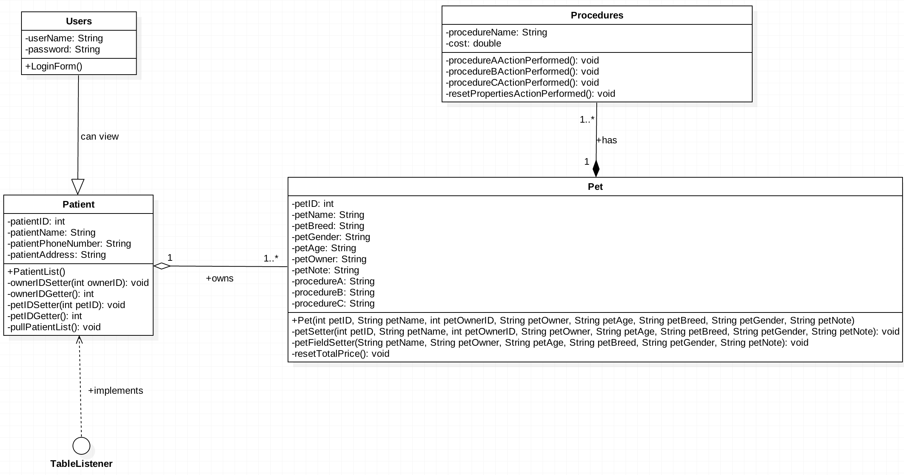

**CHAPTER 3**

**IMPLEMENTATION & DESIGN**

**3.0 User Interface**

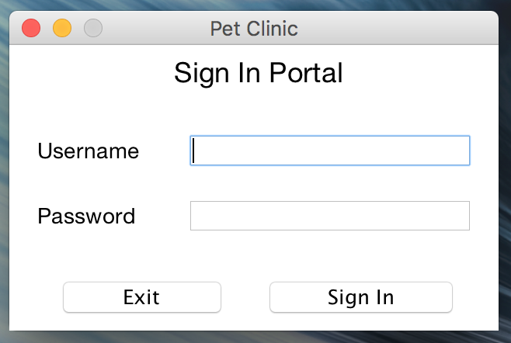

Figure 3.1: Login Form

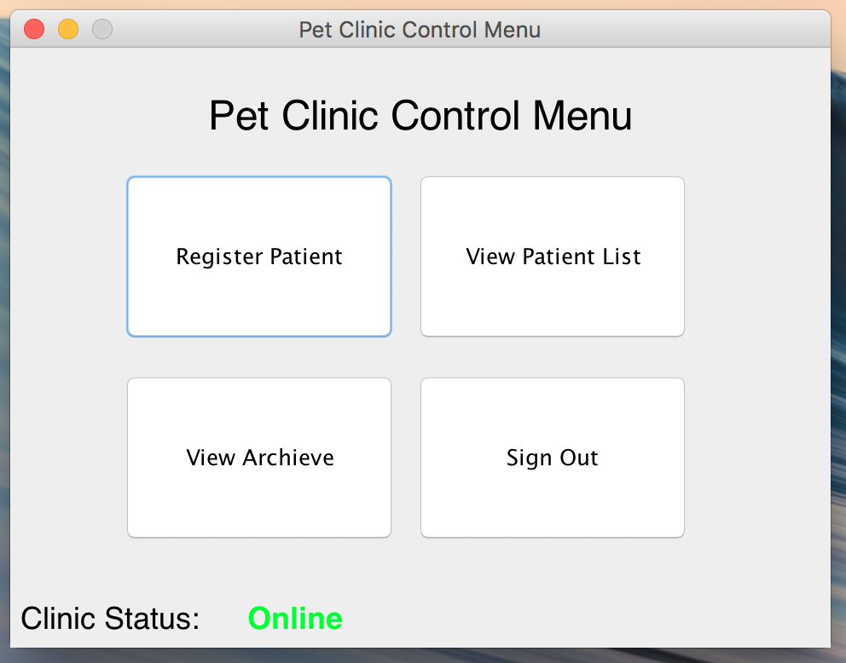

Figure 3.2: Control Menu

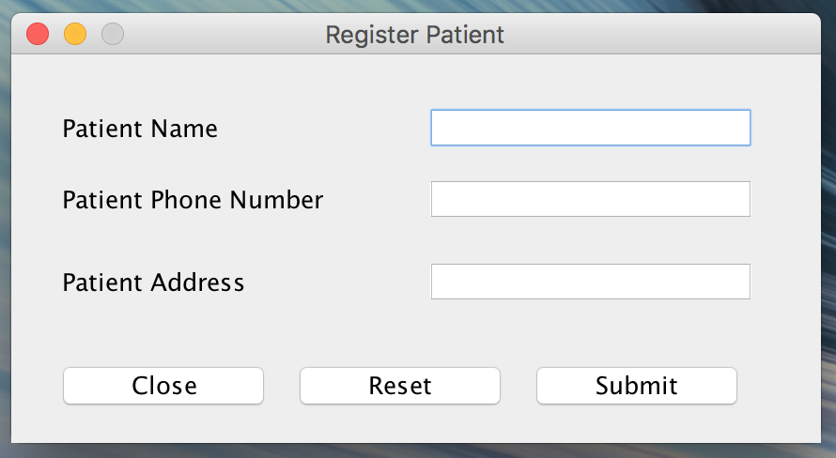

Figure 3.3: Patient Registration

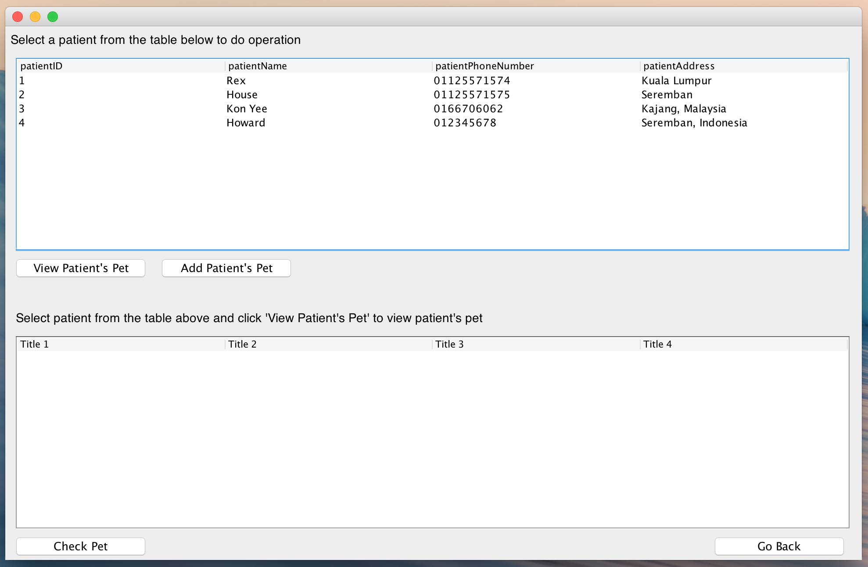

Figure 3.4: Patient List

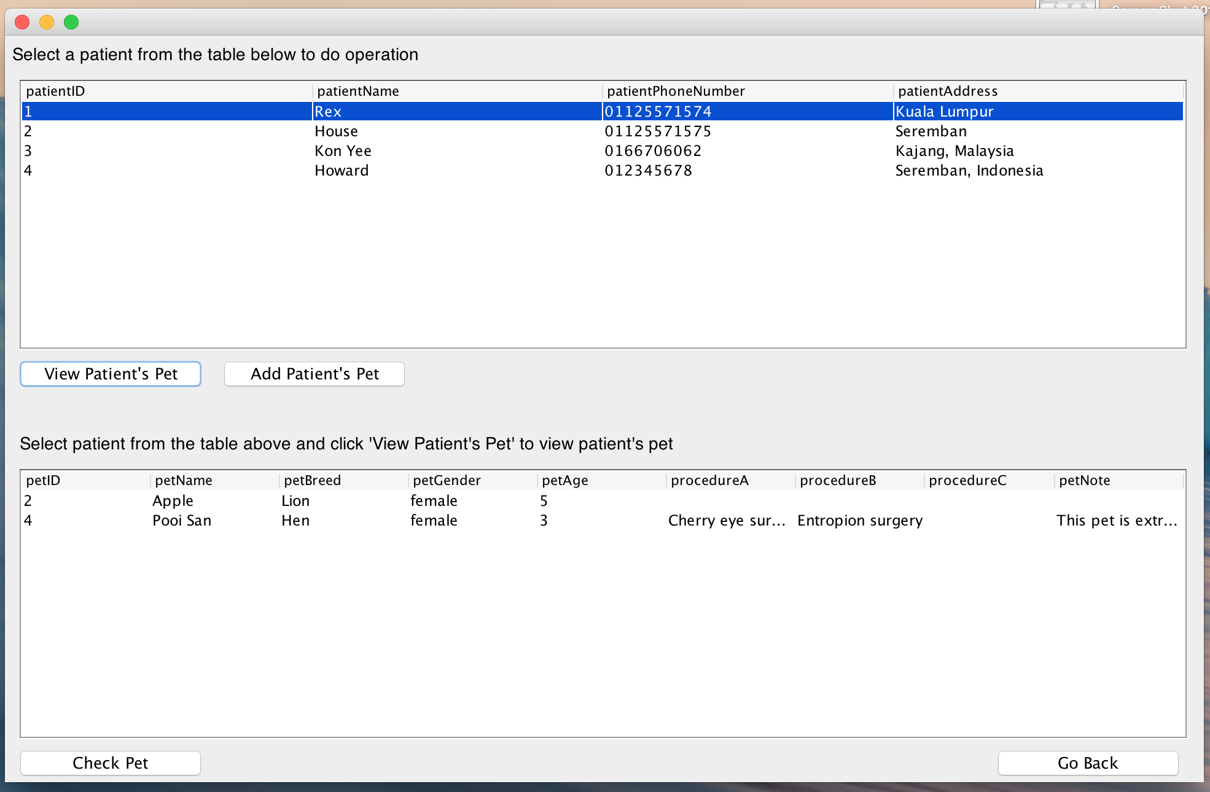

Figure 3.5: View Patient’s Pet

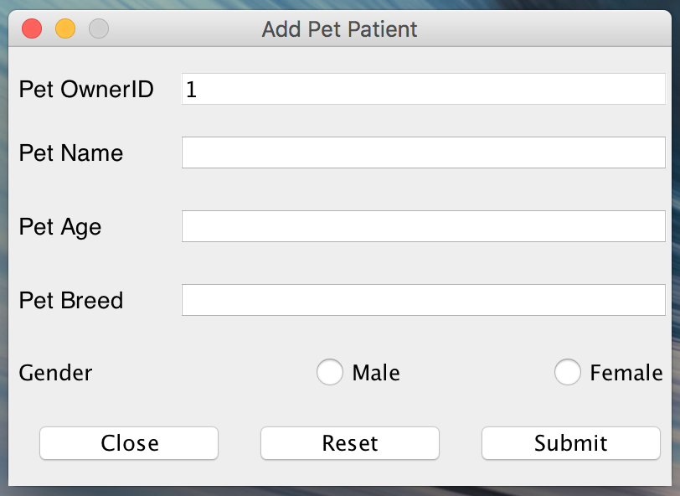

Figure 3.6: Add Patient’s Pet

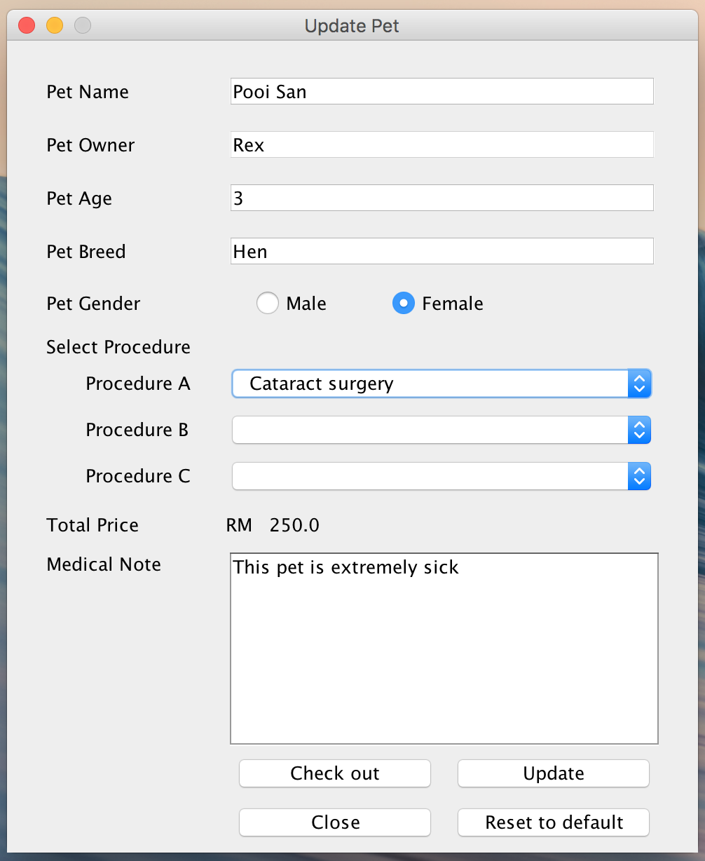

Figure 3.7: Check Out Pet Screen

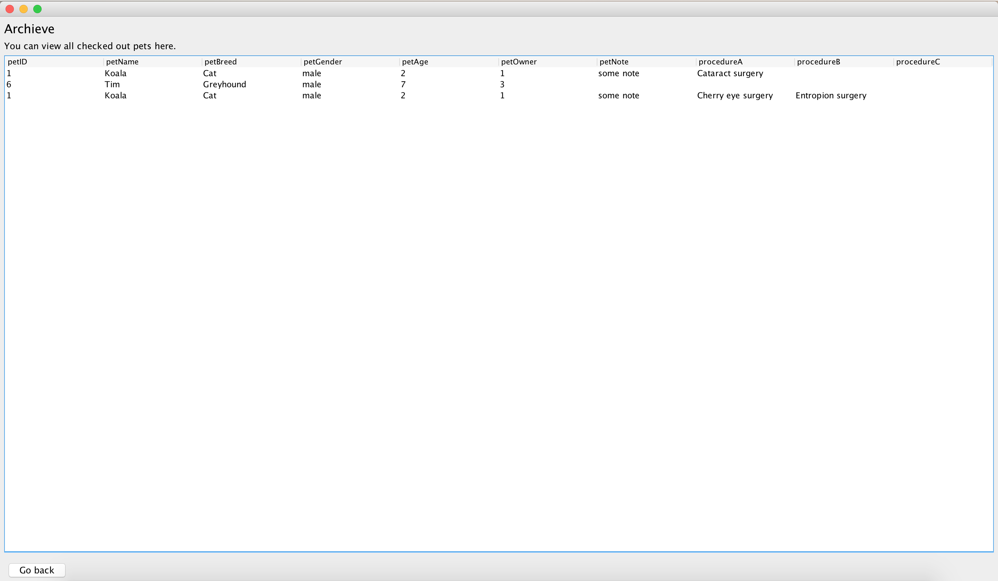

Figure 3.8: Archieve list

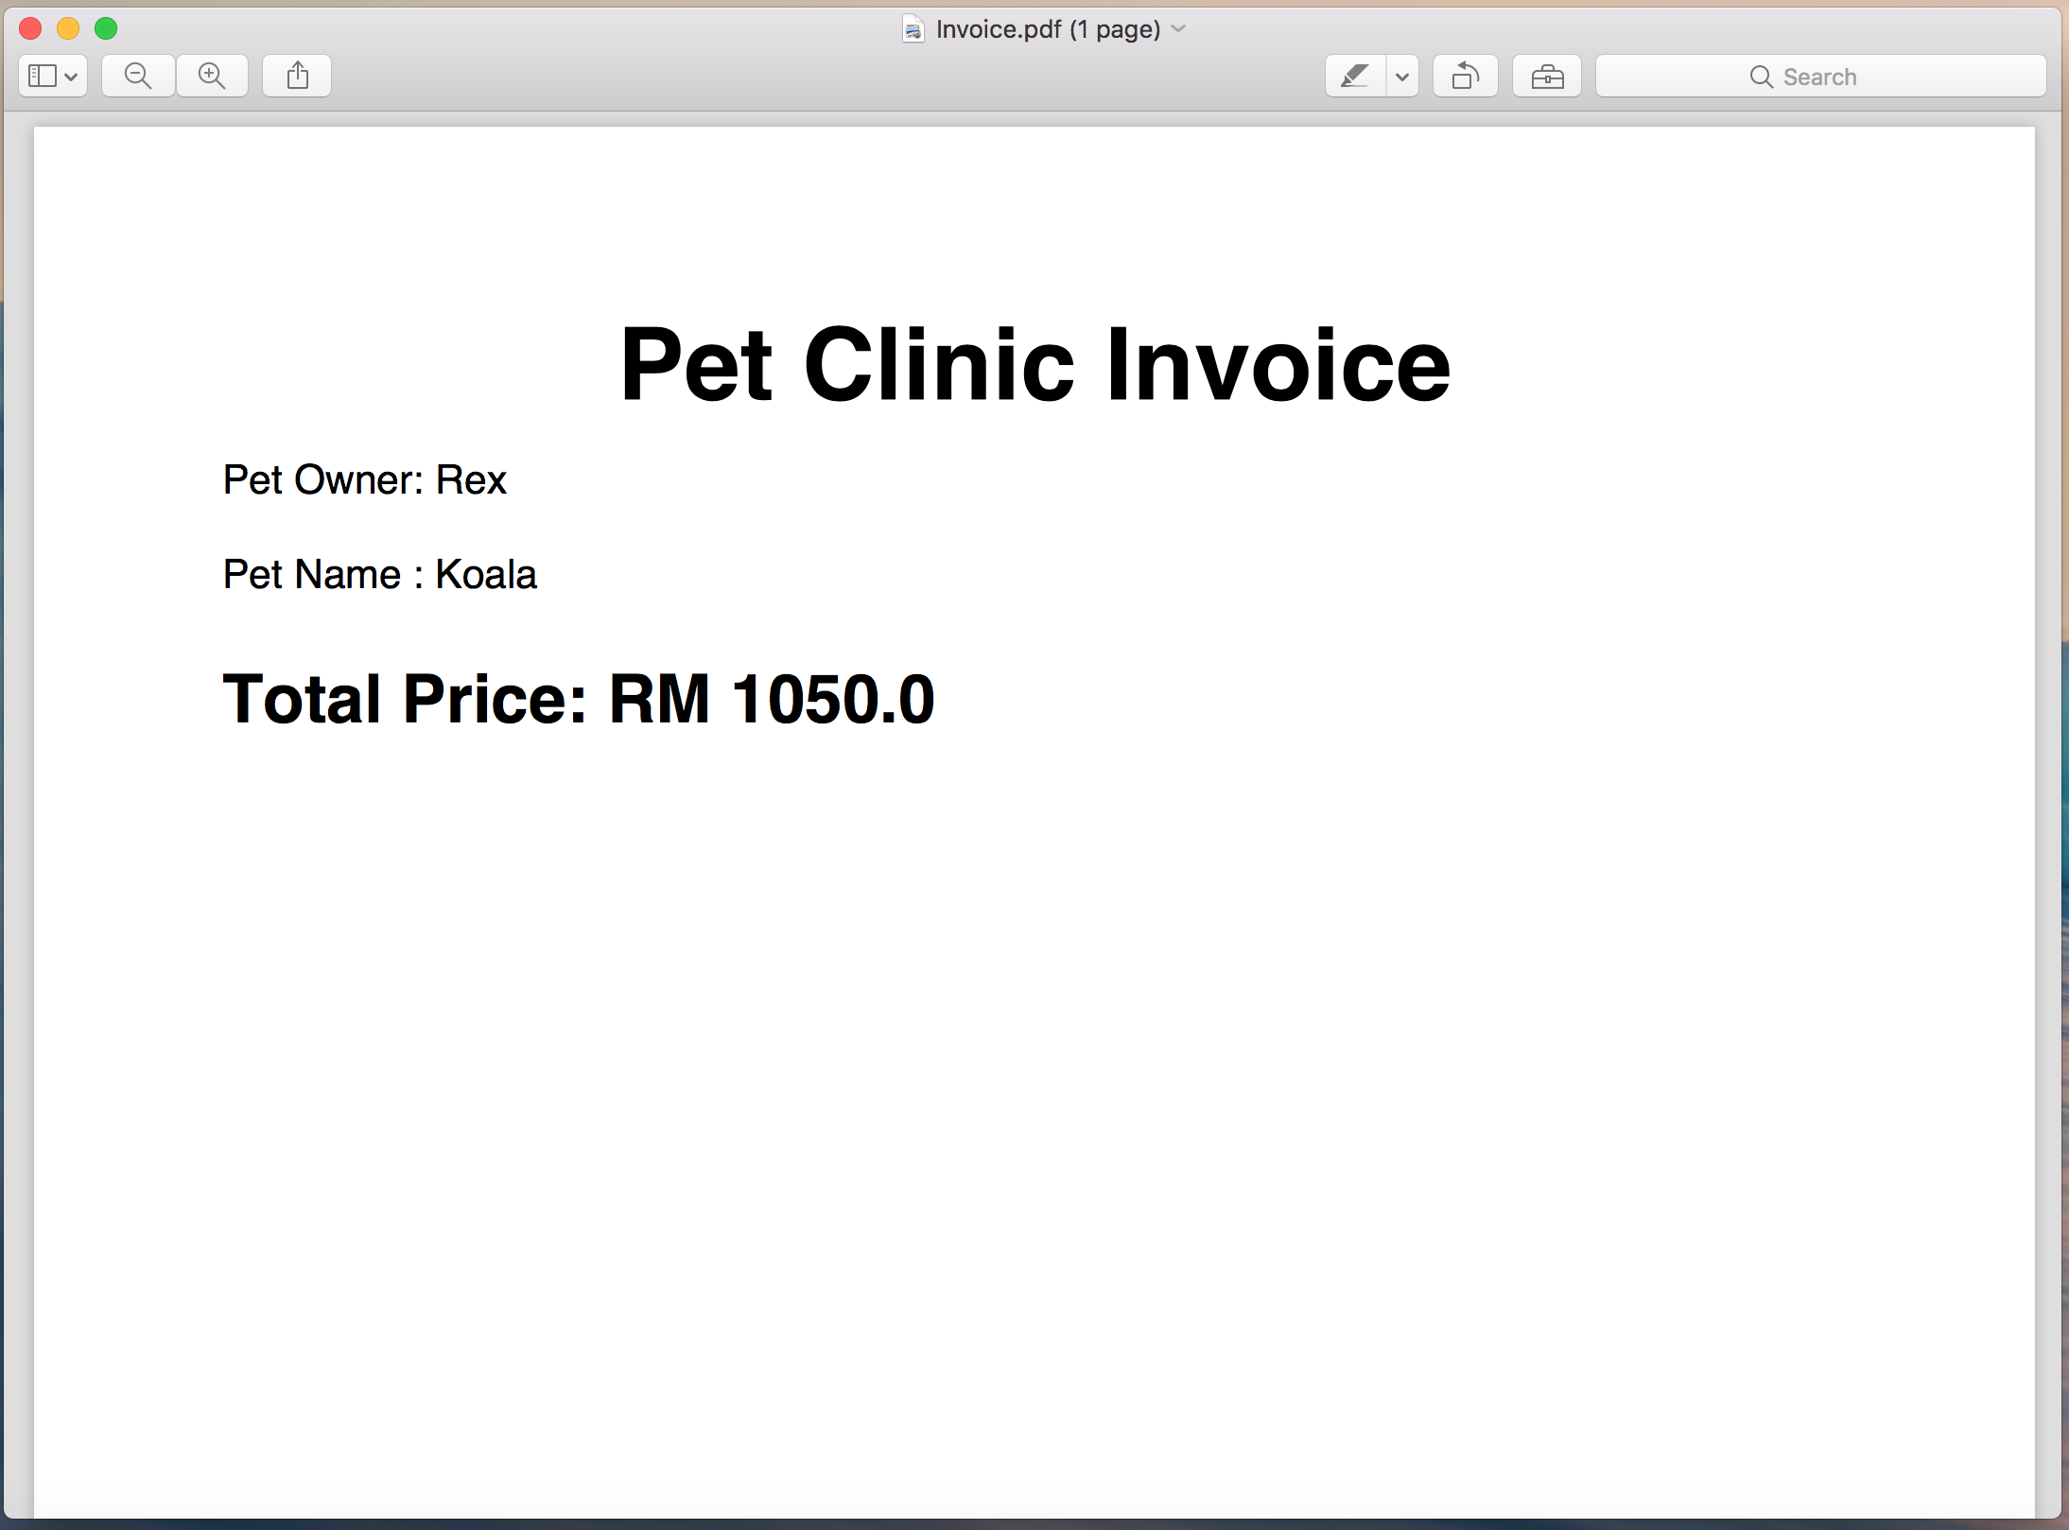

Figure 3.9: Invoice

**CHAPTER 4**

**CONCLUSION**

**4.1 Conclusion**

Pet Clinic Management System provides admin which are nurses a convenient way to manage their patient’s information well. Admin can make use of this system through several functions such as add patient, edit patient information, view patient list, add patient’s pet, check out pet, and display pet invoice to manage patient’s record in more efficient way. This could minimize the admin’s effort while they don’t need to waste time to find out patient’s record manually anymore.